***Virginia Junior Classical League***

*presents this*

Certificate of Excellence

*to*

Grace Duckworth

*of*

Brooke Point High School

*for*

*1st Place in Other*

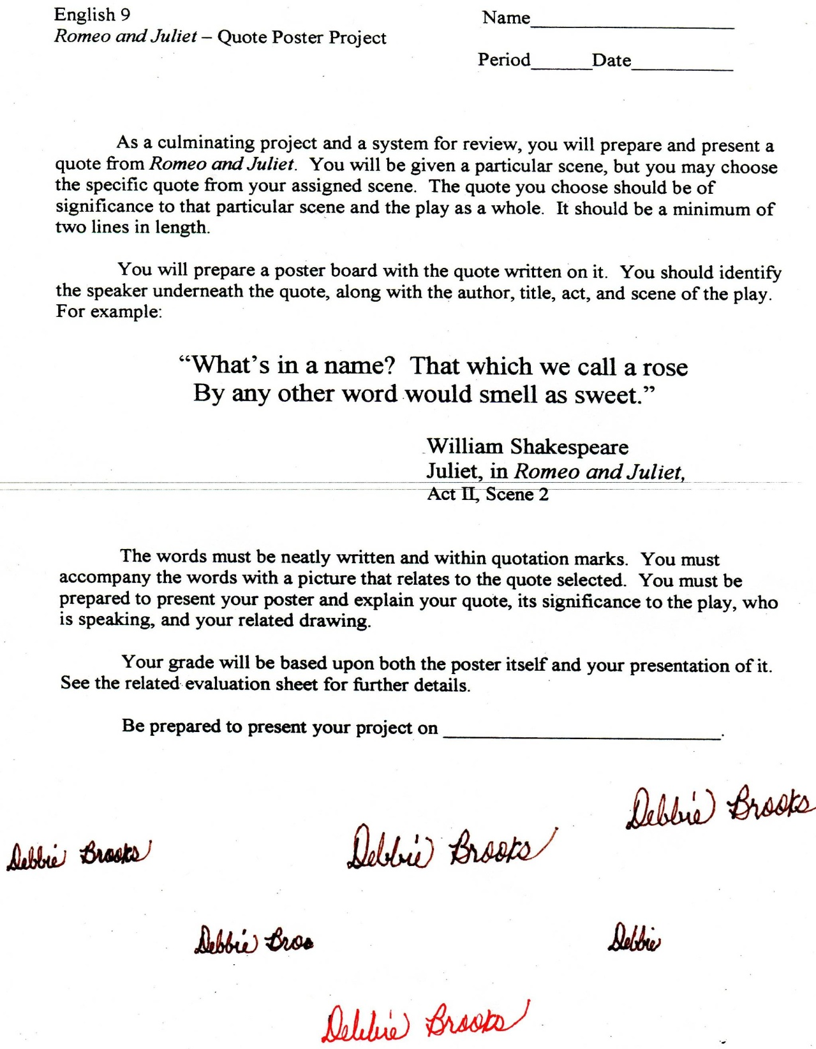

Microsoft Office Signature Line...

*a.d. viii Kal. Dec. MMDCCLXVII A.U.C. 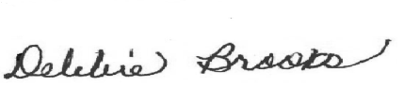*

***Virginia Junior Classical League***

*presents this*

Certificate of Excellence

*to*

Julie Gazzoli

*of*

Brooke Point High School

*for*

*2nd Place in Large Model*

**

Microsoft Office Signature Line...

*a.d. viii Kal. Dec. MMDCCLXVII A.U.C. *

***Virginia Junior Classical League***

*presents this*

Certificate of Excellence

*to*

Caleb Reynolds

*of*

Brooke Point High School

*for*

*3rd Place in Maps*

**

Microsoft Office Signature Line...

*a.d. viii Kal. Dec. MMDCCLXVII A.U.C. *

***Virginia Junior Classical League***

*presents this*

Certificate of Excellence

*to*

Tabitha Macko

*of*

Brooke Point High School

*for*

*3rd Place in Small Models*

**

Microsoft Office Signature Line...

*a.d. viii Kal. Dec. MMDCCLXVII A.U.C. *

***Virginia Junior Classical League***

*presents this*

Certificate of Excellence

*to*

Caleb Reynolds

*of*

Brooke Point High School

*for*

*4th Place in Geography*

**

Microsoft Office Signature Line...

*a.d. viii Kal. Dec. MMDCCLXVII A.U.C. *

***Virginia Junior Classical League***

*presents this*

Certificate of Excellence

*to*

Grace Duckworth

*of*

Brooke Point High School

*for*

*4th Place in Life*

**

Microsoft Office Signature Line...

*a.d. viii Kal. Dec. MMDCCLXVII A.U.C. *

***Virginia Junior Classical League***

*presents this*

Certificate of Excellence

*to*

Julie Gazzoli

*of*

Brooke Point High School

*for*

*9th Place in Life*

**

Microsoft Office Signature Line...

*a.d. viii Kal. Dec. MMDCCLXVII A.U.C. *

***Virginia Junior Classical League***

*presents this*

Certificate of Excellence

*to*

Keegan Pursley

*of*

Brooke Point High School

*for*

*10th Place in Life*

**

Microsoft Office Signature Line...

*a.d. viii Kal. Dec. MMDCCLXVII A.U.C. *

***Virginia Junior Classical League***

*presents this*

Certificate of Excellence

*to*

Jacob Ivener

*of*

Brooke Point High School

*for*

*10th Place in Small Models*

**

Microsoft Office Signature Line...

*a.d. viii Kal. Dec. MMDCCLXVII A.U.C. *